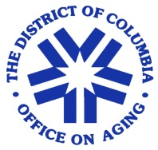
Lifespan Respite Care Volunteer Application
District of Columbia Office on Aging
500 K Street NE Washington, D.C. 20002

Name: Date of Birth:
Gender:

Address:
Home Phone: Cell Phone:

Email:
Ward:

Emergency Contact:
Name:
Address:
Relationship:
Home Phone: Cell Phone:

Do you have reliable transportation? Please check or circle all that apply.
Personal Vehicle ___ Taxi ___ Metro___ Metro Access___

Have you ever been convicted of a misdemeanor or a felony? Yes or No
If yes, please explain:
Are you at least 18 years old? Yes No
Referral Source:
Address:
Business Phone:

Qualifications: Describe your qualifications and why you can make a contribution to the lifespan respite volunteer program: _____________________________________________________________________________
_____________________________________________________________________________________
_____________________________________________________________________________________

Availability | 8 am -12 pm | 12 pm- 4 pm | 4 pm-8 pm | Desired Ward to Work in?
Sunday
Monday
Tuesday
Wednesday
Thursday
Friday
Saturday

Volunteer Signature: ______________________________________________ Date:________
- All applicants are subject to background checks requirements.

