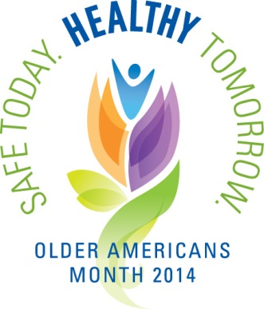
The month of May is observed annually as Older Americans Month to celebrate the many contributions of Older Americans to their communities. Older Americans Month this year is celebrated under the theme "Safe Today. Healthy Tomorrow.” The D.C. Office on Aging understands the importance of injury prevention and safety awareness in helping older adults remain active, healthy, safe and prepared for emergencies. Those that are able are living active lifestyles, participating in activities and giving back to the community.
Citywide Older Americans Month Activities 2014
“Safe Today. Healthy Tomorrow.”

5th-16th 31st Annual DC Senior Olympics
Department of Parks and Recreation
Medal competition in more than 15 sporting events, including, swimming, tennis, track and field, basketball, table tennis. Various locations across the city visit dpr.dc.gov or call 202-664-7153, for more information.

7th Mayor’s Third Annual Senior Symposium
8 a.m. – 4:30 p.m. Hyatt Regency Washington on Capitol Hill
400 New Jersey Avenue, NW
Registered participants will attend workshops, connect to technology, and get information on government resources in an information exhibit area.

9th Enhancing the Health & Safety of Older Americans
9 a.m. – 4 p.m. Washington Seniors Wellness Center
3001 Alabama Avenue, SE
For more information contact 202-534-4880

9th Mother’s Day Celebration
12 p.m. VIDA Senior Center
1842 Calvert Street, NW
Contact Information: Miguel Guerrero, 202-483-5800

14th Seabury Resources for Aging Ward 6 Lead Agency Open House
10 a.m. – 2 p.m. 901 A Street, NE
For more information, contact 202-727-0357

15th The East River Swing a Special Evening of Elegance
5 – 9 p.m. East River Family Strengthening Collaborative KEEN Seniors Program
Contact Information: Robin Gantt (202) 534-4880 ext 110 or Chicquita Bryant (202) 534-4880 ext 125

16th TERRIFIC, Inc. “Safe Today! Healthy Tomorrow” Health Fair
10 a.m. – 2 p.m. 19th Street Baptist Church
4606 16th Street, NW
For more information, contact 202-882-1824

14th Seabury Resources for Aging Ward 6 Lead Agency Open House
10 a.m. – 2 p.m. 901 A Street, NE
For more information, contact 202-727-0357

16th Senior Awareness Day Event
10:30 a.m. – 2 p.m. East River Family Strengthening Collaborative
Pilgrim Rest Baptist Church
4611 Sheriff Road, NE
Contact Ms. Hazel Jackson, (202) 398-1843 or 296-8283 ext 19

20th Seabury Ward 5 Senior Community Day
10 a.m. – 2 p.m. Edgewood Terrace
635 Edgewood Street, NE
For more information, contact 202-529-8701

23rd Senior Appreciation Day
1 – 3 p.m. First Baptist Senior Center
715 Randolph, Street, NW
For more information call 202-723-4313

28th Senior Health & Fitness Day Info Fair 2014
9 a.m. – 3 p.m. Bernice Fonteneau Senior Wellness Center
3531 Georgia Avenue, NW
Contact Information: 202-727-0338

